**Online Registration for College Admission**

**Of Saint Louis College**

**A Project Documentation**

**Presented to the Faculty of Information Technology**

**Saint Louis College**

**San Fernando City, La Union**

**In Partial Fulfillment of the Requirements for the Subject**

**Research Methods for IT**

**Submitted by:**

**Barnachea, Jelyn S.**

**Cachero, Marc Adrian T.**

**Ferrer, Edcel John P.**

**Ojascastro, Jorge II V.**

**March 2021**

**Chapter 1**

**Use case diagram**

**Online Registration for College Admission System**

<<include>>

Student

College server

Management

**Flowchart**

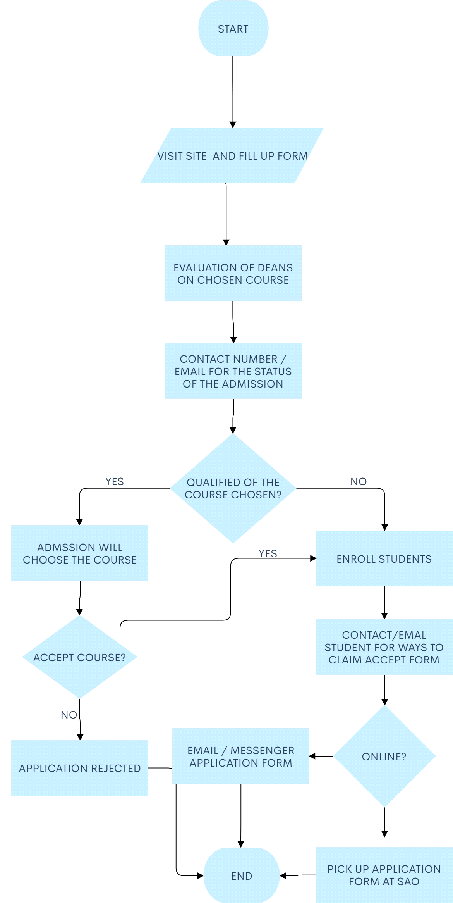

**IPO**

|  |  |  |
| --- | --- | --- |
| **Input** | **Process** | **Output** |
| Last name  First name  Middle name  Sex  Civil Status  Birth date  Birth Place  Nationality  Religion  Complete Address  Zipcode  Cellphone no.  Email address  Course | Verify if the information from the user is complete and register the user. | Notify and display a confirmation message. |